**Marching Masters**

Software Requirements Specifications

|  |  |
| --- | --- |
| **Group Members** | Brandin Bulicki, Adam Luong, Aparna  Mishra, Siddharth Srinivasan, Tumaris  Yalikun, Jeffer Zhang |
| **Faculty Advisor** | Dr. Filippos Vokolos, Ph. D. |
| **Project Stakeholder** | Baiada Institute |

Revision History

|  |  |  |  |
| --- | --- | --- | --- |
| **Name** | **Date** | **Reason for change** | **Revision** |
| Brandin Bulicki,  Adam Luong,  Aparna Mishra,  Siddharth  Srinivasan, Tumaris  Yalikun, Jeffer  Zhang | 01 November 2020 | First draft: initial outline | 1.0 |
| Brandin Bulicki,  Adam Luong,  Aparna Mishra,  Siddharth  Srinivasan, Tumaris  Yalikun, Jeffer  Zhang | 03 November 2020 | Completion of  Introduction and  Description sections | 1.2 |
| Brandin Bulicki,  Adam Luong,  Aparna Mishra,  Siddharth  Srinivasan, Tumaris  Yalikun, Jeffer  Zhang | 08 November 2020 | Initial Draft of  Requirements section | 1.4 |
| Brandin Bulicki,  Adam Luong,  Aparna Mishra,  Siddharth  Srinivasan, Tumaris  Yalikun, Jeffer  Zhang | 15 November 2020 | Updated Functional  Requirements/Added  GUI Designs | 1.5 |
| Brandin Bulicki,  Adam Luong,  Aparna Mishra,  Siddharth  Srinivasan, Tumaris  Yalikun, Jeffer  Zhang | 24 November 2020 | Completed Draft | 2.0 |

Table of Contents

**Introduction** **4**

1.1 Purpose 4

1.2 Intended Audience 5

1.3 Intended Use 5

1.4 Scope 5

1.5 Definitions and Acronyms 5

**Overall Description** **5**

2.1 Assumptions and Dependencies 5

**System Features and Requirements** **6**

3.1 Functional Requirements 6

3.1.1 Login Page 6

3.1.1.1 Login 6

3.1.1.2 Recover Password 6

3.1.1.3 Change Password 6

3.1.2 Registration 6

3.1.2.1 Registration 6

3.1.3 Home Screen (Instructor View) 7

3.1.3.1 Home Screen 7

3.1.4 Home Screen (Performer View) 7

3.1.3.1 Home Screen 7

3.1.5 Field View 7

3.1.5.1 Selection of Field View 7

3.1.5.2 Live View of Field (Instructor View) 7

3.1.5.2 Live View of Field (Performer View) 7

3.1.5.2 Recording of Field View (Performer View) 7

3.1.6 Band Information (Instructor View) 8

3.1.6.1 Creating a Band 8

3.1.6.2 Band Created 8

3.1.7 Band Information (Performer View) 8

3.1.7.1 Joining a Band 8

3.1.7.2 Leaving a Band 8

3.1.8 Documents/Events/Assignments Handling 9

3.1.8.1 Uploading Documents 9

3.1.8.2 Viewing Documents 9

3.1.9 Sending Feedback 9

3.1.9.1 Feedback to Performers 9

3.1.9.2 Drafting feedback and sending to requested recipients 9

3.1.10 Viewing Feedback 9

3.1.10.1 See history of all feedbacks from all instructors 9

3.1.10.1 See one singular requested feedback 10

3.1.11 Settings 10

3.1.11.1 User Settings 10

3.1.11.2 Drill Settings 10

3.2 Functional Requirements (GUI) 11

3.3 Nonfunctional Requirements 18

3.3.1 Tracking Speed (Performance) 18

3.3.2 Tracking Accuracy 19

4.1 User Flow 19

4.1.1 System Boundary 19

4.1.2 Activity Diagram 19

# Introduction

## 1.1 Purpose

Every summer, marching bands and drum corps all around the world learn drills for their season’s performance. Then, in the winter, indoor percussion, guard, and wind ensembles prepare their drill for their seasons. As it stands, the only way to effectively learn the coordinates (aka dots) for the show is to go ‘set-by-set’ and check every performer’s positioning for every drill move. What if there was a way to improve efficiency, just by looking at one screen? Marching Masters aims to improve these out-dated methods.

Marching Masters will increase the effectiveness of drill instruction and the proficiency with which a show is performed. This product will ultimately be the first marching based program that will allow for tracking of the performers from drill set to drill set. This system will allow staff and performers to track the movements on the field, analyze for correctness against the written drill, and be able to be reviewed by staff and performers. By obtaining this knowledge, staff will be more equipped to provide instruction and performers will be able to further understand what corrections they must make. These records will be able to be saved for review at a later time. Just because the performers are not at their rehearsal site doesn’t mean that the learning must be done. Overall, this product will be an all-in-one stop for all your band needs.

## 1.2 Intended Audience

This program will best serve all marching arts performers and staff. Instructors will be able to assign documents and information to performers assigned to him/her. Performers will be able to join a group lead under an instructor.

## 1.3 Intended Use

Individually, performers can use Marching Masters to better organize themselves and their dot books. Additionally, as a collective, the performers can better communicate with their sections, officers, as well as their staff to keep the learning going even when not physically together. On the other side, staff will also be able to communicate with other staff members with ease to keep the organization all on the same page. Staff with the necessary permissions will be able to set events, assignments, and even share documents. This all will keep the performers notified of practices and competitions, informed on points of the show that need work, keeping them up to date with all changes in drill and music.

## 1.4 Scope

Marching Masters is designed to help achieve a greater level of success in the marching arts. The program does this by allowing the director to create groups for each season or group that they instruct. They then are able to upload the drill in the form of pdf dot sheets that Marching Masters then uses to compare the location of the performer. This will inform the staff and performers whether they are accurately performing the drill as written.

The secondary functions include an editable dot book that you can load right on your device. Performers and instructors can add in notes so that the performers can easily know when visuals and other drill enhancements occur. Finally, Marching Masters will act as a social app that will allow instructors and performers to seamlessly communicate with each other. This will allow for questions to be asked and answered, assignments to be posted, and events to be added.

## 1.5 Definitions and Acronyms

There are no definitions, acronyms, or abbreviations being used at this time for Marching Masters.

# Overall Description

## 2.1 Assumptions and Dependencies

Because our application is a hybrid mobile and web platform we assume that users are proficient with both mediums. This includes understanding how to download, install and utilizes their device inputs to navigate Marching Masters. The dependency that our application has is that each device that our platform runs on has access to either wifi or mobile data. Because our platform provides real time data for positioning we need the internet to sync users together.

# System Features and Requirements

## 3.1 Functional Requirements

#### 3.1.1 Login Page

###### 3.1.1.1 Login

If the user is not logged into the application, they will be presented with the login page. The user will need to fill in the “Email” and “Password” boxes to be able to proceed. In case the password is forgotten, the user can click on the “Forgot your password?” button to reset their password. Clicking the button will take them to the “Recover Password” page. Below the “forgot your password?” button is “Create an account” button which will take the user to the “Registration Page”. Once all information is correctly typed, the user can proceed by clicking on the “Login” button.

###### 3.1.1.2 Recover Password

The recover password page has the textbox “Email” for the user to enter their registered email address. If they want to return to the previous page, they can click on the “back” button to return. Below the “Email” box is a “Reset password” button, which will send an email to the user’s email address to reset the password. Once the “Recover Password” button is pressed, there will be a popup to indicate an email has been sent to reset password. The email contains a link which will prompt the user with a temporary password. The user can copy and paste it to their login page which will direct them to a “Change Password” page.

###### 3.1.1.3 Change Password

The password reset page has two text boxes, “New password” and “Re-enter new password”. Both boxes need to match in order for it to take effect. Once they finish typing the matching passwords, they can click on the “Change Password” button to use the application.

#### 3.1.2 Registration

###### 3.1.2.1 Registration

The user will need to fill in the text boxes. The boxes are “First Name”, “Last Name”, “Email”, and “Password”. The password needs to be 8 characters minimum with no spaces, includes letters, and at least 1 number. There is a “show\hide” button next to the “Password” box to show or hide the text. Below all the text boxes, there will be a drop down to select if the user is an instructor or a performer. When all required information is filled in, the user can click on the “Sign up” button to get registered.

#### 3.1.3 Home Screen (Instructor View)

###### 3.1.3.1 Home Screen

The Home Screen for Instructor View will open to a page similar to Field View with no representation of performer drill spots or tracking shown. This will allow for the instructor users to open a live view of the field or a previously recorded field.

#### 3.1.4 Home Screen (Performer View)

###### 3.1.3.1 Home Screen

The Home Screen for Performer View will open to a page similar to Field View with no representation of performer drill spots or tracking shown. This will allow for the performer users to open a live view of their location on the field or a previously recorded field.

#### 3.1.5 Field View

###### 3.1.5.1 Selection of Field View

The Field View Page will represent the field in which the drill has been written. The default setting will be for the traditional high school football field, with hashes 53’ 4’’ from each sideline. Additionally, a grid will be shown on the field representing standard 8-to-5 steps (22.5”).

###### 3.1.5.2 Live View of Field (Instructor View)

When using the live view feature, the instructor users will be given a live viewpoint of the current field with all members shown.

###### 3.1.5.2 Live View of Field (Performer View)

When using the live viewpoint feature, the performer users will be shown their current locations on the field and the location of their current set.

###### 3.1.5.2 Recording of Field View (Performer View)

When using the recorded viewpoint feature, the performer user will be shown their path travelled and the correct path.

#### 3.1.6 Band Information (Instructor View)

###### 3.1.6.1 Creating a Band

The defaulted landing page when the band icon is clicked on the home screen would result in the “Creating a Band” configuration. This configuration has a single button title “Create a Band” and a back button on the top left-hand side of the page. When the back button is clicked the screen will go back to the home page. When the “Create a Band” button is clicked a unique 6 digit pin will be generated. This pin will now be associated with the instructor in a database.

###### 3.1.6.2 Band Created

After the “Create a Band” button is clicked in the “Creating a Band” configuration the screen will now populate the ID in a text box on the page. Right below the text box will be a “Disband Group”. When clicked the band will be “disbanded” meaning all the performers associated with the unique band ID will now be kicked and each performer will now get a notification on their home screen saying “Band ID is now disbanded” and the Band Page for the performers will now be the “Joining a Band” configuration. The ID will now be disassociated in the database and will not be used again for any other band IDs. Beneath the textbox will be a running list of all the marchers. On the top left-hand side of this page will be a back button that, when clicked, will change the page to the home screen.

#### 3.1.7 Band Information (Performer View)

###### 3.1.7.1 Joining a Band

The default landing page when the band icon is clicked on the home screen would result in the “Joining a Band” configuration. When this configuration is landed on the page will display a text box, a button marked “Join Band” and a back button. The text box will allow the user to enter at most 6 digits corresponding to the band ID the user chooses to join. When the “Join Band” button is pressed there will be a lookup for the band ID enter. If the ID pulls up an existing band the performer will now be associated with that band. If the textbox has less than 6 digits, is empty, or is an invalid ID the user will be notified on-screen with the message “Invalid Band ID.”

###### 3.1.7.2 Leaving a Band

When a performer joins a band they will enter the “Joined a Band” configuration. Here the page will have a top text box with the band ID. Below that will be a text box with the instructor’s name. Below that will be a button marked “Leave Band” which when clicked will remove the performer from the associated band ID and revert the page to the “Joining a Band” configuration. Below that will be a running list of all the performers in the band. Clicking the back button will send the performer back to the home page.

#### 3.1.8 Documents/Events/Assignments Handling

##### 3.1.8.1 Uploading Documents

If the user would like to upload any documents to their account, the user can click on the “Upload” button on the homepage. On the “Upload” page, there are three buttons. The buttons are “Upload Document”, “Upload Event”, and “Upload Assignment”. Each button upon being pressed will take the user to a screen with one button. The button, “browse local files”, will allow the user to upload a document specific to the button they pressed.

##### 3.1.8.2 Viewing Documents

On this page, the user will be able to view any documents that they have uploaded or that the instructor has uploaded. Once the button “View” is pressed on the home screen, the user will be directed to the “View” page which contains 3 different buttons. This page contains the “View Documents”, “View Events”, and “View Assignments” buttons. The user will be able to view any documents that they have uploaded or that the instructor has uploaded by clicking the “View Documents” button. The user will be able to view any events that they have by clicking the “View Events” button. If the user wants to see any assignments that they have, they can see by clicking the “View Assignment” button.

### 3.1.9 Sending Feedback

##### 3.1.9.1 Feedback to Performers

The feedback page will allow instructors to see the “Send Feedback to All Performers” button on the top. On the bottom below “Current Performers”, there will be buttons for each of the performer’s names. Upon clicking any of the buttons, it will take the recipient (whether all performers or specific performers) and go to the “Create Feedback Page”.

##### 3.1.9.2 Drafting feedback and sending to requested recipients

The Create Feedback Page will have the specific recipient up top and a “Send” button right below. Below the “Send” button will be a text field that also opens up the keyboard on your mobile device to allow instructors to type in. Upon clicking “Send”, it will go back to the Feedback Page.

### 3.1.10 Viewing Feedback

##### 3.1.10.1 See history of all feedbacks from all instructors

The Feedback History Page will allow all performers to see their own individual history of feedback(s) written and sent by instructors. Inside each feedback field, it will have the name of the instructor as well as the feedback. If the feedback does not fit in the space, it will show a “...” at the very last character allowed. Upon clicking on any of the feedback bubbles, it will lead to the “View Specific Feedback Page”.

##### 3.1.10.1 See one singular requested feedback

The View Specific Feedback Page will allow all performers to see one specific feedback. On the top will be which instructor created and sent the feedback. On the bottom of that is an enlarged field that shows the entire feedback.

### 3.1.11 Settings

##### 3.1.11.1 User Settings

User settings will allow users to create a profile, configure email preferences, edit display name and manage new user features.

##### 3.1.11.2 Drill Settings

Drill settings will allow users to adjust the field environment to suit that of the drill. This includes changing the grid from a 4-step grid (Default) to a 3-step grid. Additionally field settings can be adjusted from the default high school football field, to either college or professional fields.

# 3.2 Functional Requirements (GUI)

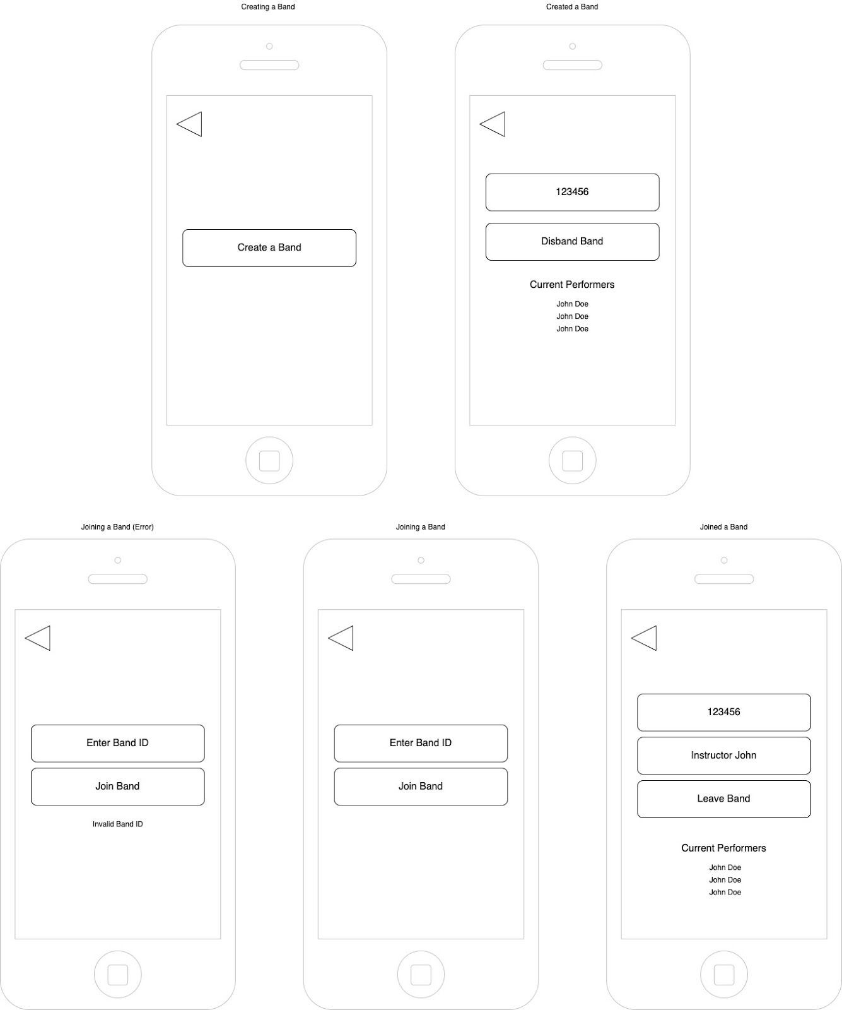

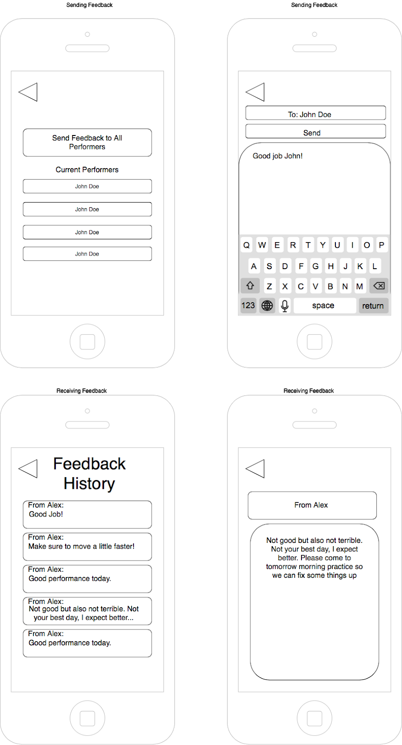

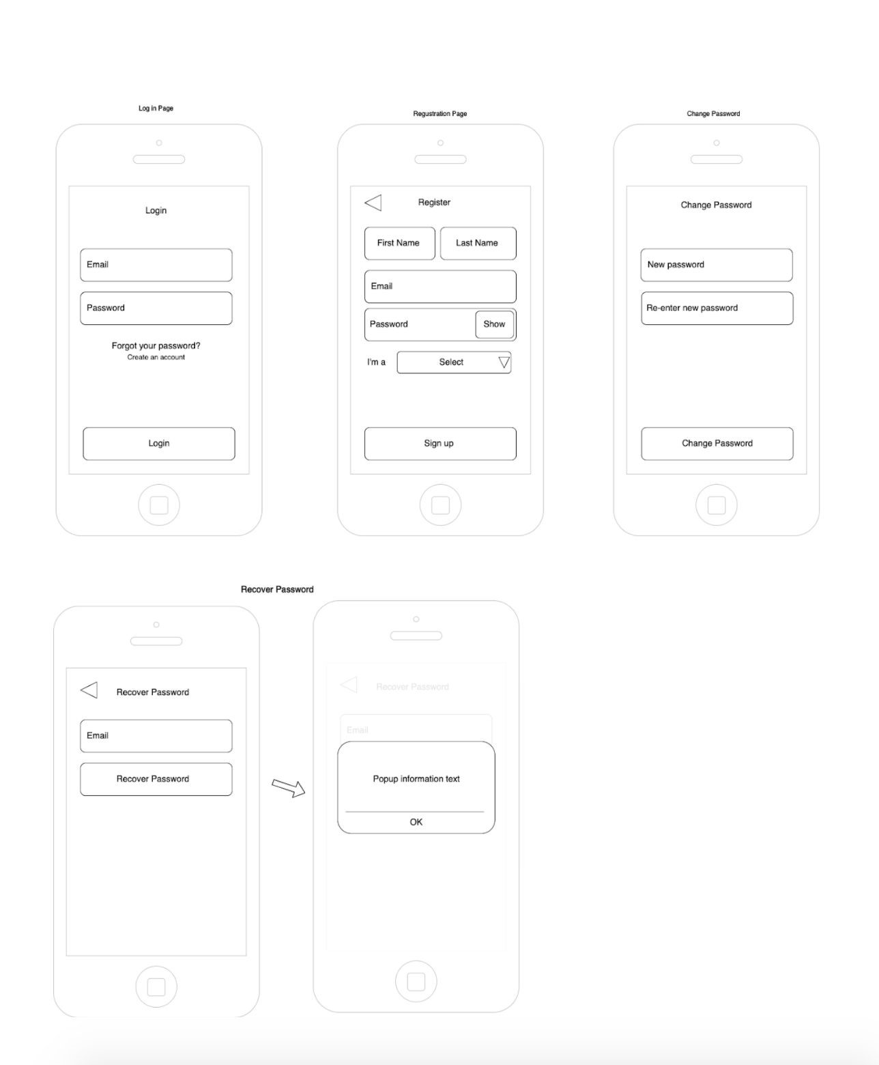

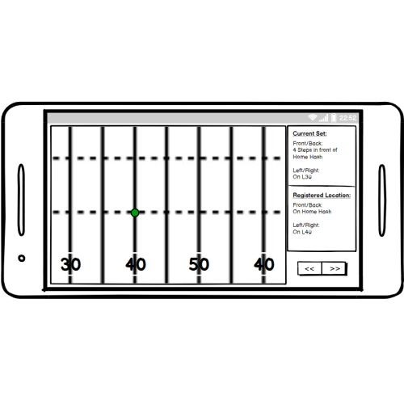

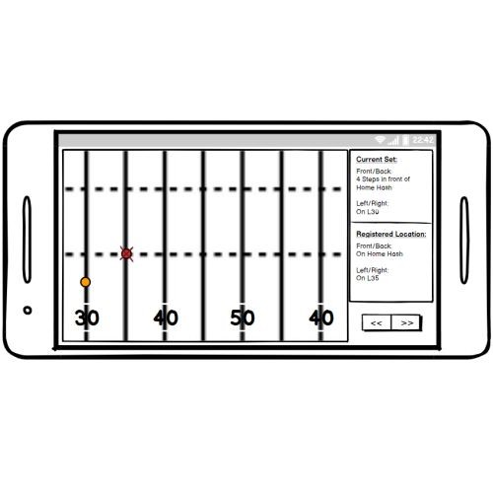

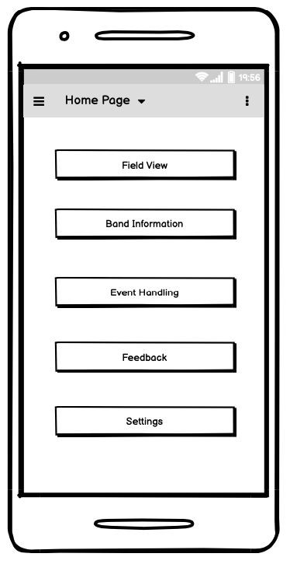

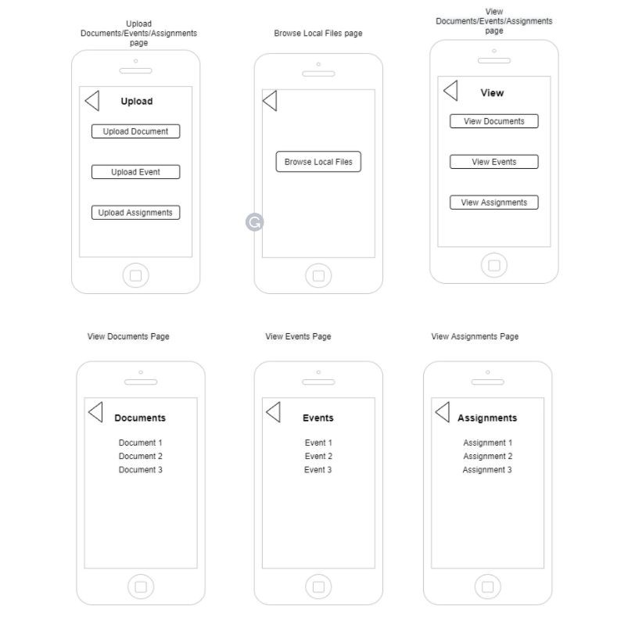

# 3.3 Nonfunctional Requirements

### 3.3.1 Tracking Speed (Performance)

Due to the necessity of being able to obtain real-time information on each of the performers, the delay time should not exceed 5ms (the refresh rate of the IMU device). Therefore, for each movement of a performer the information relayed to the main display should be <5ms.

3.3.2 Tracking Accuracy

The data obtained from the performers will be displayed and aggregated on a main display. This would visualize the field on the device our application is running. Relatively speaking, each dot representing a performer should be scaled to the field displayed on the screen accordingly. Therefore, the distance error between each dot or performer that is received should not exceed 10%.

4.1 User Flow

4.1.1 System Boundary

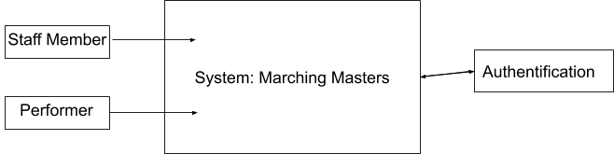

4.1.2 Activity Diagram

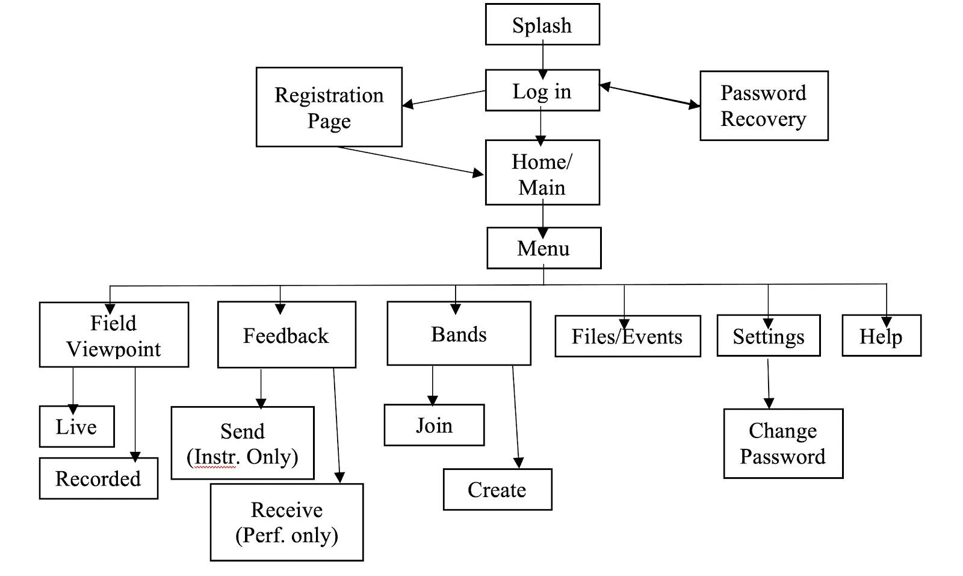

Review

* Who is the lead of each section?
* Can a person be involved in multiple marching?
* I would suggest that you add history tab in the prototype.
* The SRS looks good, its descriptive covers most of the important points
* What database are you using to save the information/ you do not seem to mention that in your SRS
* I will also recommend encrypting the password in your database for customer confidentiality